2015 IEEE Antennas and Propagation Symposium
and
URSI North American Radio Science Meeting

Vancouver, British Columbia

Lot Shafai
University of Manitoba
Winnipeg, Manitoba
204-510-1599 shafai@ee.umanitoba.ca

David G. Michelson
University of British Columbia
Vancouver, BC
604 822-3544 davem@ece.ubc.ca

Rodney G. Vaughan
Simon Fraser University
Burnaby, BC
778-782-6889 rodney_vaughan@sfu.ca

Table of Contents

I. About Vancouver 2
II. Committee Structure and Appointments 3
A. Technical Program Committee 4
B. Publicity Committee 4
C. Publications Committee 5
D. Meeting Planners 5
III. Proposed Meeting Dates and Schedule 5
IV. Conference Facility 6
V. Local Arrangements 10
A. Getting to Vancouver 11
B. Hotels 12
C. Restaurants and Shopping 12
D. Social Program 12
E. Technical Tours 15
VI. Preliminary Schedule 16
VII. Budget Summary: 17

19 July 2010

About Vancouver
Vancouver, Canada looks forward to hosting the 2015 IEEE Antennas and Propagation Symposium and URSI North American Radio Science Meeting.
The Setting. With 2.2 million residents, Vancouver is the largest metropolitan area in Western Canada and the third largest in the country. It offers a stunning combination of modern architecture, sophisticated shopping and leading edge entertainment projected against a spectacular natural backdrop of mountains, forests and ocean. Its climate is temperate by Canadian standards and is usually classified as “Marine West Coast”. The summer months are typically dry and ideal for all types of outdoor recreational activities.
Parameter | July | Year
Record high °C (°F) | 34.4 (93.9) | 34.4 (93.9)
Average high °C (°F) | 21.7 (71.1) | 13.7 (56.7)
Average low °C (°F) | 13.2 (55.8) | 6.5 (43.7)
Record low °C (°F) | 6.7 (44.1) | −17.8 (-0)
Rainfall mm (inches) | 39.6 (1.559) | 1,154.7 (45.461)
Avg. rainy days (≥ 0.2 mm) | 6.9 | 161.3
Sunshine hours | 294.5 | 1,928
The Vancouver Experience. Vancouver residents are ethnically and linguistically diverse; 52% do not speak English as their first language. As a result, the city provides visitors with an extremely cosmopolitan and multi-cultural experience. Vancouver hosted both the 2010 Winter Olympics and the 1986 World’s Fair (Expo 86) and serves as Canada’s Asia-Pacific Gateway. Greenpeace was founded here almost forty years ago; sustainability and environmental issues remain civic priorities. Vancouver is highly rated as both a place to live and as a travel and conventions destination:
‘Top North American Destination for International Meetings’  ‘Best City in the Americas’  ‘The World’s Most Livable City’  ‘Top Canadian Destination’  ‘Top North American Destination’  Canada’s “Most Walkable City” | The International Congress and Convention Association (ICCA), 2009  Condè Nast Traveler, 2009  Economist Intelligence Unit, 2008  Travel & Leisure Magazine, 2009  The Daily Telegraph, 2009  Up Magazine!, 2009
The Digital Media and Wireless Economy. Anchored by Nokia, Sierra Wireless, the Digital Media and Wireless Association of BC and the Wavefront Wireless Commercialization Centre, the digital media and wireless sector in BC includes over 1150 companies that generate revenues of over $3 billion and employ 16,500 people. Radio frequency technology figures prominently at major federally-funded research facilities such as the TRIUMF particle accelerator laboratory near UBC and the Dominion Radio Astrophysical Observatory near Penticton.
IEEE Vancouver Section has over 2200 members and is the second largest in Canada. It recently received the IEEE MGA Outstanding Section Award .

Committee Structure and Appointments
Members of the Symposium Committee will be drawn from academia in Western, Central and Atlantic Canada and from industry in the Pacific Northwest.
General Chair: Prof. Lot Shafai, U Manitoba
Vice-Chairs: Prof. Dave Michelson, UBC
Prof. Rodney Vaughan, SFU
Technical Program Committee:
Chair: Prof. Costas Sarris, U Toronto
IEEE AP-S Co-chair: Prof. Sean Hum, U Toronto
URSI Co-chair: Prof. Y.M.M. Antar, RMCC
Local Arrangements: Prof. Rodney Vaughan, SFU
Prof. Dave Michelson, UBC
Finance: Prof. Sujeet K. Chaudhuri, U Waterloo
Registration: Dr. Amiee Chan, Norsat International
Short Courses and Workshops: Dr. Ping Hui, Nokia
Dr. Lixin Cai, Boeing
Student Programs Liaison: Prof. Zhizhang (David) Chen, Dalhousie U
Publicity and Call for Papers: Prof. Jens Bornemann, UVic
Dr. Jasmin Roy, CRC
Digest Publications: Dr. Behrouz Pourseyed, Sierra Wireless
Corporate Sponsorships: Dr. Charles W. Manry, Jr., Boeing
Prof. Poman So, UVic
Exhibits: James Maynard, Wavefront
Michael Bidu, DigiBC
Meeting Planners: To be selected by competitive bid.
Candidates include Experient, Conference
Management Systems & Three Dimensions.
AP-S Liaison: To be assigned by AP-S
URSI Liaison: To be assigned by URSI
Visas and International: Dr. Lixin Cai, Boeing
Technical Tours: Dr. Bruce Veidt, DRAO
Webmaster: To be selected by the meeting planner in
consultation with the committee.
Members at Large: Sol Lancashire, BC Hydro
John Murtagh, TELUS
Duncan Sharp, Planetworks
Helen K. Pan, Intel

Technical Program Committee
The Technical Program will be coordinated by Profs. Costas Sarris and Sean Hum (University of Toronto) and Prof. Y.M.M. Antar (Royal Military College of Canada). Members of the technical program committee will represent a variety of technical areas in order to support the broad scope of the URSI and AP-S areas of interest. A list of the suggested topic areas, based upon those solicited by past symposia, is provided below:

1. Adaptive array signal processing | 26. Military applications
2. Active and smart antennas | 27. MIMO systems
3. Biomedical applications | 28. Mobile and PCS antennas
4. Biomedical imaging | 29. Monolithic array techniques
5. Broadband antennas | 30. Multi-band antennas
6. Complex media | 31. Nano-electromagnetics
7. Conformal Antennas | 32. Negative-index and left-handed media
8. Digital beamforming | 33. Numerical methods
9. Electrically small antennas | 34. Optimization methods in EM design
10. Electromagnetic bandgap structures | 35. Phased-array antennas
11. Electromagnetic education | 36. Photonics
12. Electromagnetic theory | 37. Propagation
13. EM measurements | 38. Radar imagery
14. EM properties of materials | 39. Random media and rough surfaces
15. FDTD methods | 40. Reconfigurable antennas and arrays
16. FEM methods | 41. Reflector antennas
17. Frequency-selective surfaces | 42. Remote sensing
18. High frequency and asymptotic methods | 43. Scattering, diffraction, and RCS
19. Indoor and urban propagation models | 44. Terahertz applications
20. Integral equation methods | 45. Time-domain integral equations
21. Inverse scattering | 46. Ultra-wideband antennas
22. Measurement techniques | 47. Ultra-wideband systems
23. Metamaterials and applications | 48. Waveguiding structures
24. Microstrip antennas and arrays | 49. Wearable Antennas
25. Microstrip devices and circuits | 50. Other topics

Publicity Committee
The Publicity Committee will be responsible for advertising the Symposium and for generating interest throughout the AP-S community. Accordingly, the Committee will:
- Design or commission a suitable logo for stationery, posters and advertisements.
- Establish liaison with the IEEE for special mailings of announcements, calls for papers and advance programs to all members.
- Distribute two calls for papers throughout the antennas and propagation community, including universities, companies, IEEE/AP-S members and URSI members.
- Publish an Advance Program with the assistance of the Technical Program Committee.
- Publish announcements and advertisements in appropriate technical publications.
- Submit articles as appropriate to various technical journals and magazines in order to promote the symposium and inform potential participants.

Publications Committee
The publications committee will work with the meeting planner to:
- Publish the AP-S and URSI symposium digests on CD or DVD or other digital media in PDF format.
- Coordinate publication of conference materials with IEEE Xplore.

Meeting Planners
Meeting planning will be coordinated by a professional conference management firm to be selected through a competitive bid process. The firm will be contracted to arrange, coordinate and implement many of the conference support services, such as hotel and/or convention centre contract negotiations, audio/visual equipment proposals/contracts, food and beverages, registration, social events, exhibit layouts, meeting room layouts, etc.

Proposed Meeting Dates and Schedule
We recommend that the symposium be held during the week of 19 – 25 July 2015. For reference, the International Microwave Symposium will be held in Phoenix from 15-22 May 2015 and the European Microwave Week will be held in Paris from 26-30 October 2015. At the time of the writing of this proposal, IEEE has not posted its business meeting schedule.
The schedule of technical, business and social events at the Symposium will be similar to those at past symposia. The evening schedule will be shifted slightly in order to accommodate the Celebration of Light fireworks display that will likely be held that week in the vicinity of English Bay (a ten-minute walk from the hotel). On the next page, see the aerial view of the downtown area with key sites labeled.

Proposed Symposium Schedule - 2015

 | AM | Lunch | PM | Evening
Sunday | Business Meetings Short Courses |  | Business Meetings Short Courses | Business Meetings
Monday | AP-S & URSI | Business Meetings | AP-S & URSI | Reception
Tuesday | AP-S & URSI | Business Meetings | AP-S & URSI | Banquet
Wednesday | AP-S & URSI | Business Meetings | AP-S & URSI | Fireworks
Thursday | AP-S & URSI | Business Meetings | AP-S & URSI | Panel Session
Friday | AP-S & URSI | Business Meetings | AP-S & URSI | _
Saturday | Short Course & Workshops |  | Short Courses & Workshops | Fireworks

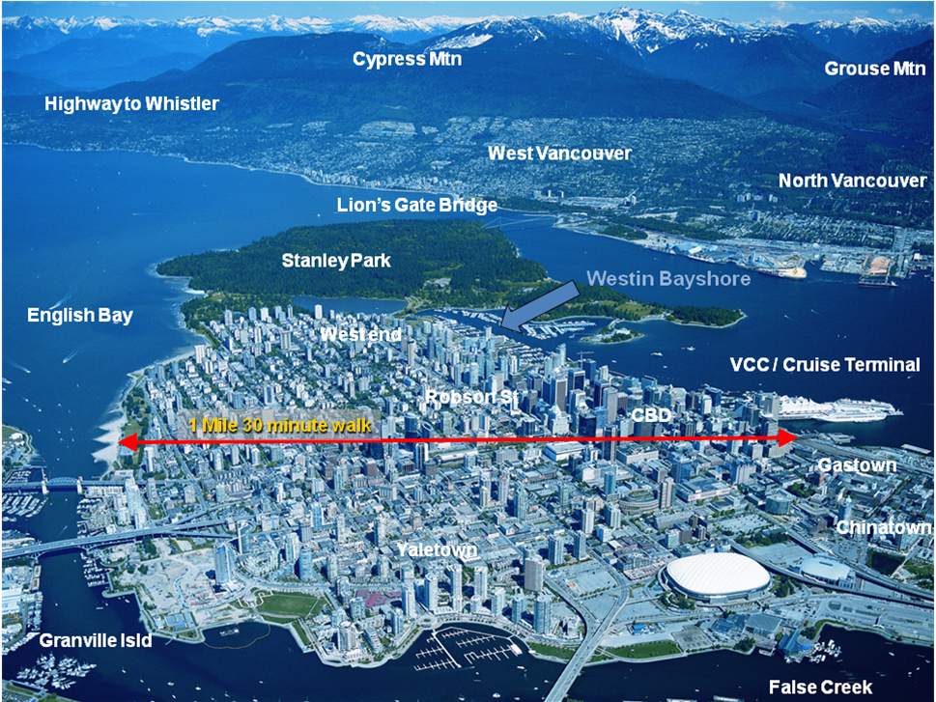
Aerial view of Downtown Vancouver.

Conference Facility
The conference venue will be selected through a competitive bid process that will involve at least three candidates amongst the hotels in downtown Vancouver, including: 1) the Westin Bayshore Hotel, 2) the Vancouver Convention Centre, and 3) the Fairmont Pacific Rim/Fairmont Waterfront Hotels. All are located on the waterfront and are only minutes away on foot from other hotels and places of interest such as Canada Place, Stanley Park, Denman Street and Robson Street.
The Westin Bayshore Hotel is particularly attractive because it has the largest complement of meeting rooms of any single hotel in Vancouver and can uniquely provide both accommodation and meeting space in a single package. Only the Vancouver Convention Centre has more meeting space under one roof. Thus, the Westin Bayshore is cited here as an example.
Floor plans of the lobby level and second floor of the Westin Bayshore hotel are shown on the next page. Three very large spaces are available for use during the banquet, technical exhibits, and interactive sessions. Fifteen rooms with a capacity of greater than 100 participants are available for use during technical sessions. At least ten smaller rooms are available for use during business meetings. A handful of smaller rooms may be used as speaker ready rooms or office space.
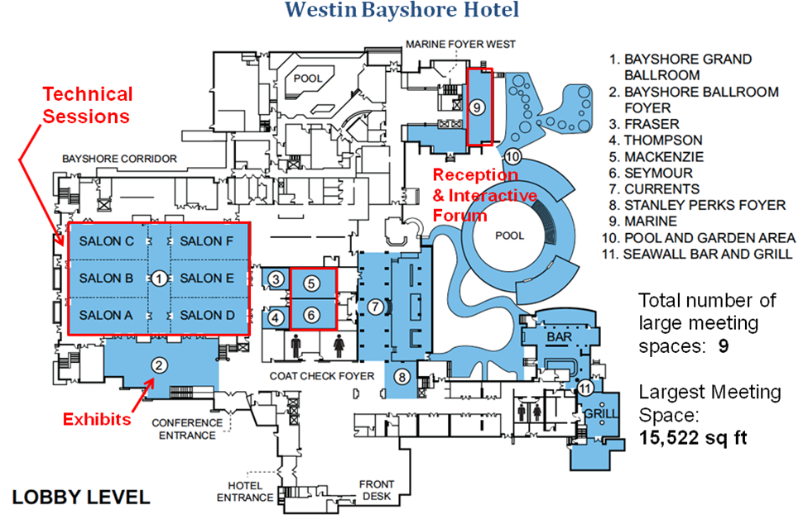
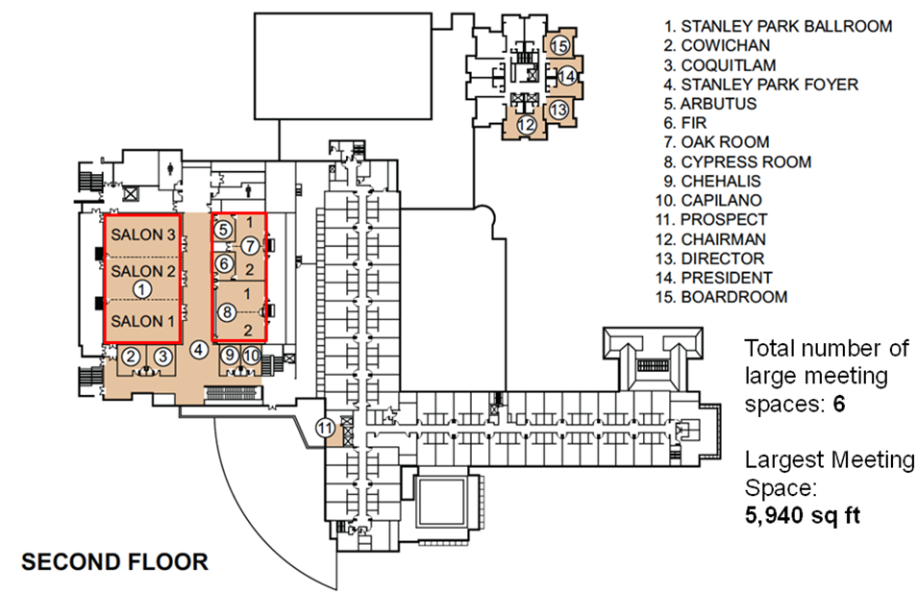

The proposed room plan for the Westin Bayshore Hotel is tabulated below:

Rooms | Purpose
Pool and Garden Area | Interactive Forum
Ballroom Foyer | Exhibits, Refreshments
Stanley Park Foyer | Refreshments
Salon A | Technical Presentations 1
Salon B | Technical Presentations 2
Salon C | Technical Presentations 3
Salon D | Technical Presentations 4
Salon E | Technical Presentations 5
Salon F | Technical Presentations 6
Marine | Technical Presentations 7
Mackenzie | Technical Presentations 8
Seymour | Technical Presentations 9
Cypress 1 | Technical Presentations 10
Cypress 2 | Technical Presentations 11
Oak Room | Technical Presentations 12
Salon 1 | Technical Presentations 13
Salon 2 | Technical Presentations 14
Salon 3 | Technical Presentations 15
Stanley Park Ballroom | Reviewers' Luncheon
Grand Ballroom | Awards Banquet
Coat Check | Registration Room and Desk
Pool and Garden Area | Opening Reception
Ballroom Foyer | Registration
Capilano | Business Meetings and Luncheons 1
Chehalis | Business Meetings and Luncheons 2
Arbutus | Business Meetings and Luncheons 3
Director | Business Meetings and Luncheons 4
Fir | Business Meetings and Luncheons 5
Boardroom | Business Meetings and Luncheons 6
Fraser | Business Meetings and Luncheons 7
Thompson | Business Meetings and Luncheons 8
Coquitlam | Business Meetings and Luncheons 9
Cowichan | Business Meetings and Luncheons 10
President | Business Meetings and Luncheons 11

Detailed room specifications are provided in the tables on the following two pages.
Westin Bayshore Hotel – Meeting Room Capacities

Meeting Room | Floor | Length | Ceiling | Area (#) | Rounds | Theater | Conference
Pool and Garden Area | 1 | 122'*177' | 0'-0' | 14565 | - | - | -
Bayshore Ballroom Foyer | 1 | 99'11"*35' | 29'11" | 7433 | - | - | -
Stanley Park Foyer | 2 | 43'*249'11" | 20' | 3398 | - | - | -
Salon A | 1 | 33'*68' | 18' | 2244 | 180 | 290 | 65
Salon B | 1 | 33'*68' | 18' | 2244 | 180 | 290 | 65
Salon C | 1 | 33'*68' | 18' | 2244 | 180 | 290 | 65
Salon D | 1 | 33'*68' | 18' | 2244 | 180 | 290 | 65
Salon E | 1 | 33'*68' | 18' | 2244 | 180 | 290 | 65
Salon F | 1 | 33'*68' | 18' | 2244 | 180 | 290 | 65
Marine | 1 | 20'11"*60' | 14'2" | 1503 | 120 | 32 | 36
MacKenzie | 1 | 39'*25'11" | 8'2" | 981 | 80 | 120 | 34
Seymour | 1 | 39'*25'11" | 8'2" | 981 | 80 | 120 | 34
Cypress 1 | 2 | 37'11"*24' | 12' | 912 | 80 | 100 | 34
Cypress 2 | 2 | 37'11"*24' | 12' | 912 | 80 | 100 | 34
Oak Room | 2 | 22'11"*50'11" | 12' | 1176 | 100 | 130 | 46
Salon 1 | 2 | 60'*33' | 16' | 1980 | 180 | 250 | 50
Salon 2 | 2 | 60'*33' | 16' | 1980 | 180 | 250 | 50
Salon 3 | 2 | 60'*33' | 16' | 1980 | 180 | 250 | 50
Stanley Park Ballroom | 2 | 99'*60' | 16' | 5940 | 540 | 750 | -
Capilano | 2 | 16'*18'11" | 10' | 303 | 20 | 24 | 16
Chehalis | 2 | 16'*18'11" | 10' | 303 | 20 | 24 | 16
Arbutus | 2 | 21'5"*14' | 12' | 350 | 30 | 30 | 16
Director | 2 | 20'*16' | 8'3" | 351 | 20 | 30 | 16
Fir | 2 | 21'5"*14' | 12' | 353 | 30 | 30 | 16
Boardroom | 2 | 19'5"*20' | 8'3" | 386 | 20 | 30 | 16
Fraser | 1 | 18'11"*22' | 8'2" | 409 | 30 | 40 | 20
Thompson | 1 | 18'11"*22' | 8'2" | 419 | 30 | 40 | 20
Coquitlam | 2 | 22'*18' | 10' | 446 | 30 | 35 | 20
Cowichan | 2 | 22'*18' | 10' | 448 | 30 | 35 | 20
President | 2 | 27'11"*18'11" | 8'3" | 564 | 40 | 50 | 26

Westin Bayshore Hotel – Meeting Room Capacities (cont)

Meeting Room | Conference | Reception | Classroom | U-Shape | Hollow [ ]
Pool and Garden Area | - | - | - | - | -
Bayshore Ballroom Foyer | - | 800 | - | - | -
Stanley Park Foyer | - | 700 | - | - | -
Salon A | 65 | 250 | 160 | 70 | 80
Salon B | 65 | 250 | 160 | 70 | 80
Salon C | 65 | 250 | 160 | 70 | 80
Salon D | 65 | 250 | 160 | 70 | 80
Salon E | 65 | 250 | 160 | 70 | 80
Salon F | 65 | 250 | 160 | 70 | 80
Marine | 36 | 200 | 75 | 36 | -
MacKenzie | 34 | 100 | 70 | 40 | 50
Seymour | 34 | 100 | 70 | 40 | 50
Cypress 1 | 34 | 75 | 50 | 34 | 40
Cypress 2 | 34 | 75 | 50 | 34 | 40
Oak Room | 46 | 120 | 80 | 46 | 44
Salon 1 | 50 | 200 | 120 | 50 | 60
Salon 2 | 50 | 200 | 120 | 50 | 60
Salon 3 | 50 | 200 | 120 | 50 | 60
Stanley Park Ballroom | - | 600 | 420 | 100 | 120
Capilano | 16 | 40 | 16 | 12 | 16
Chehalis | 16 | 40 | 16 | 12 | 16
Arbutus | 16 | 25 | 16 | 15 | -
Director | 16 | 20 | 12 | 15 | 18
Fir | 16 | 25 | 16 | 15 | -
Boardroom | 16 | 25 | 12 | 15 | 16
Fraser | 20 | 30 | 20 | 20 | 20
Thompson | 20 | 30 | 20 | 20 | 20
Coquitlam | 20 | 40 | 20 | 20 | 20
Cowichan | 20 | 40 | 20 | 20 | 20
President | 26 | 40 | 24 | 22 | 26

Local Arrangements

Getting to Vancouver
Vancouver International Airport, locally referred to as ‘YVR’, is consistently rated among the top airports in the world for overall passenger satisfaction. It is serviced by 40 carriers that offer hundreds of direct flights to cities throughout Europe and Asia and thousands of direct flights to North American destinations each week. On a busy summer day, YVR will serve some 700 arriving and departing aircraft with routes from 25-minutes to 15-hours in length. More information about YVR can be found at http://www.yvr.ca.
Few conference attendees will either want or need to rent a car. The downtown peninsula and waterfront area of Vancouver is very compact and friendly to pedestrian traffic. Public transit in Vancouver is outstanding. Transportation from YVR to downtown is provided by Airporter bus and the new Canada Line Rapid Transit to Waterfront Station next to the Vancouver Convention Centre.
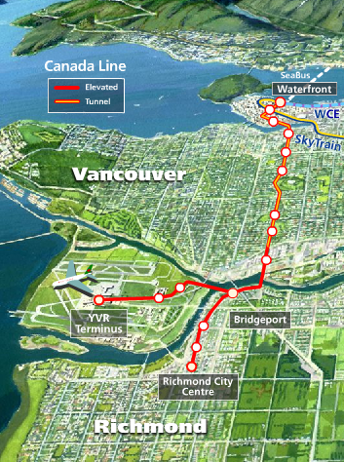
Some conference attendees may wish to arrive or depart by cruise ship. The main cruise ship terminal is co-located with the Vancouver Convention Centre.
Other attendees will want to drive their own cars to Vancouver. The city is connected to the rest of Canada by the Trans-Canada highway; to Washington state, Oregon and California by Interstate 5; and to Vancouver Island by several passenger ferry routes operated by BC Ferries Corp.

Hotels
As the map below suggests, there are several thousand hotel rooms available within a short walk (fifteen minutes or less) from the Westin Bayshore hotel.

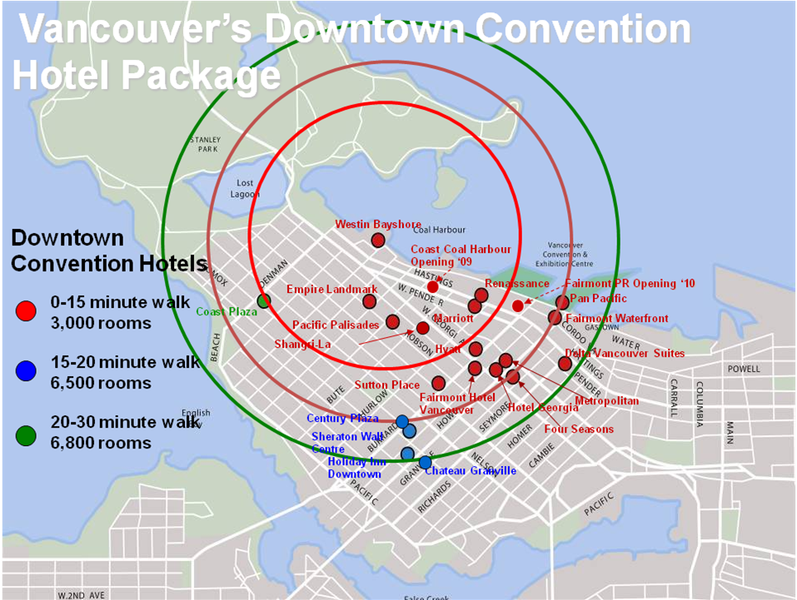

Restaurants and Shopping
Given its diverse cultural heritage, it’s not a surprise that Vancouver offers an exceptional array of dining and shopping experiences that will satisfy a broad range of tastes and expectations. Within the downtown core, the principal dining and shopping areas are the waterfront between Stanley Park and Canada Place, Denman Street and Robson Street. The vast majority are located within a ten-to-fifteen-minute walk from the conference venue. Slightly further afield are Granville Street, Gastown, Yaletown and Davie Street. These are located within a twenty-to-thirty-minute walk from the conference venue and are likely more suitable for evening activities.

Social Program
The conference social program will include: 1) evening events during the technical sessions, 2) daytime events on the Sunday prior to the start of the technical sessions and 3) daytime events during the technical sessions. The first and second sets are intended for all attendees while the last set is intended mostly for accompanying families.
Evening events will include the welcome reception, the conference banquet, the Celebration of Light fireworks and the panel session and pizza night. Smaller groups may wish to attend the Bard on the Beach at Kitsilano Point or Theatre under the Stars in Stanley Park.
Daytime social events include tours of the city by open bus, boat cruise or float plane; cycling; sea kayaking and assorted activities in Stanley Park and the vicinity of English Bay; and visits to the Capilano Suspension Bridge and Grouse Mountain (via the Skyride.).
Group visits to Science World, the MacMillan Space Centre, the Vancouver Aquarium, the UBC Museum of Anthropology, the Pacific Museum of the Earth at UBC, the Vancouver Art Gallery and the Vancouver Police Museum are among numerous other possibilities.
The pre- or post-conference travel possibilities are numerous and may include day over overnight trips to Victoria, Whistler, Manning Park, the Okanagan Valley, or Seattle, or even a cruise to Alaska via the Inside Passage or a trip to the Rockies by ViaRail.
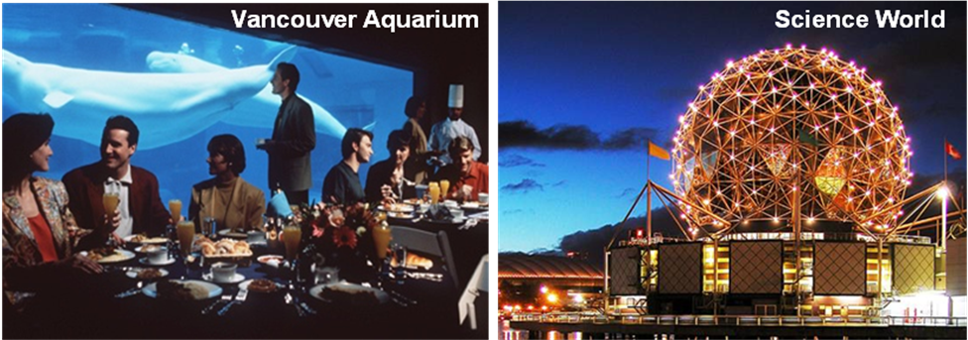
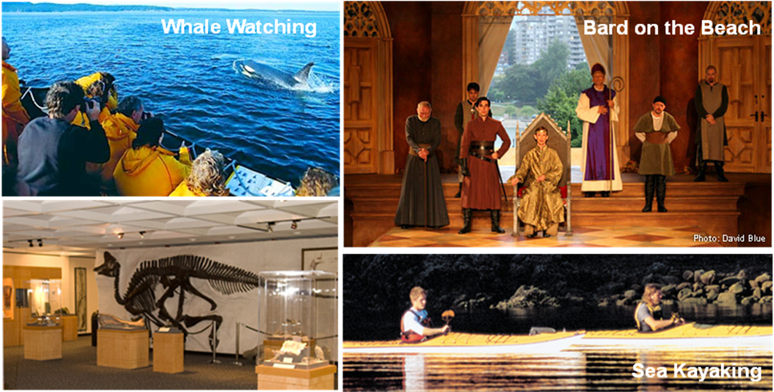
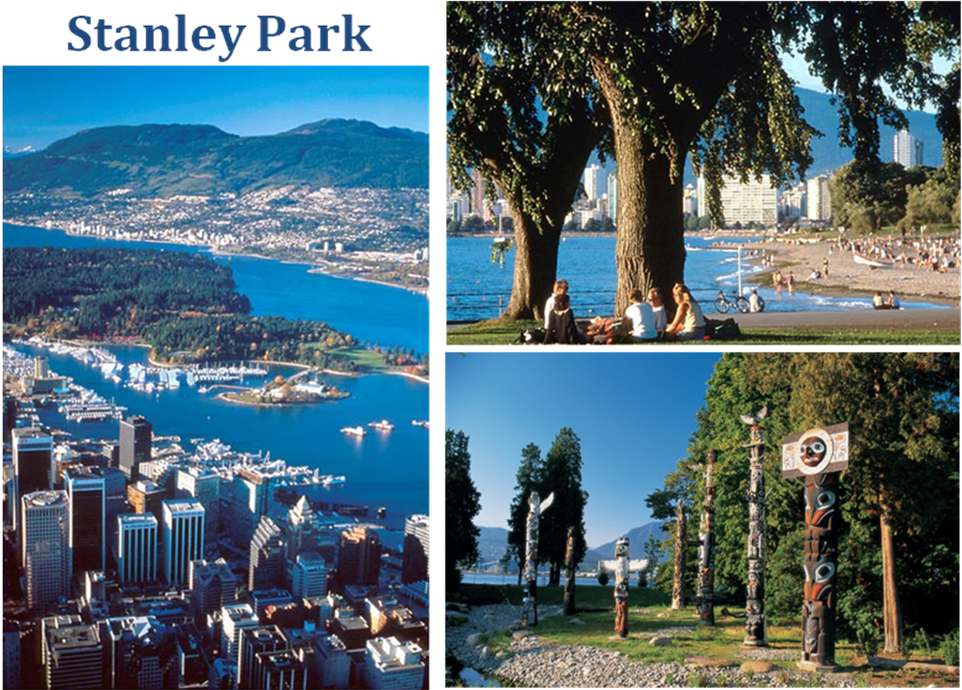
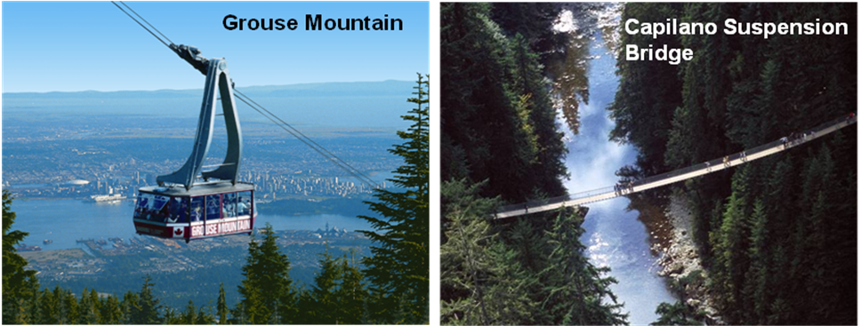
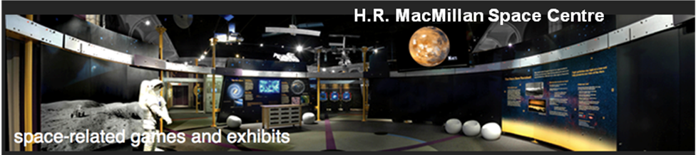
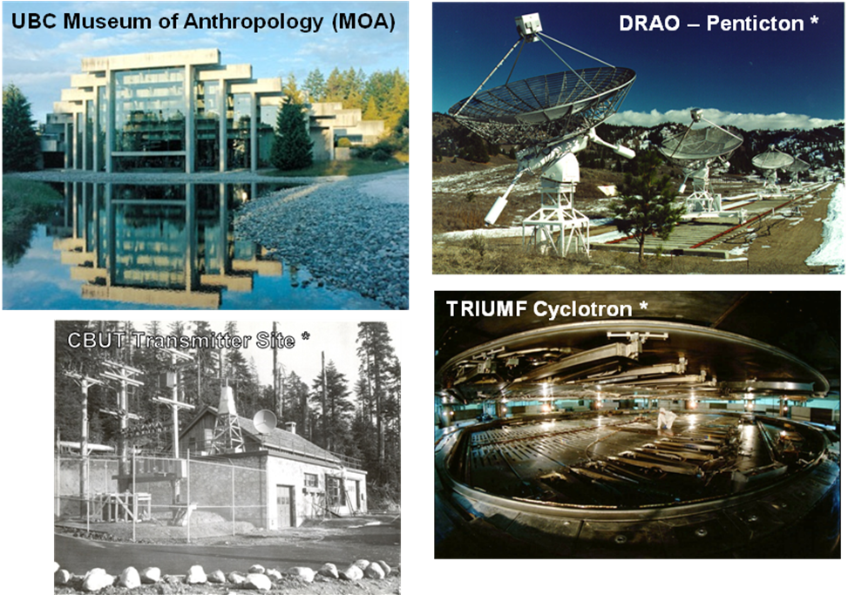

Technical Tours
Several technical tours will be offered to APS/URSI 2010 attendees. Three sites that have recently been designated as Milestones by the IEEE Board of Directors will be of particular interest. The first site is within walking distance of the conference venue. A shuttle bus will be provided for the last three tours.
1. Vancouver Vessel Traffic Management System/Harbour Air Traffic Control (Harbour Centre, Vancouver)
From separate control towers that are co-located atop Harbour Centre, Canadian Coast Guard and Nav Canada personnel monitor ship and seaplane traffic in the vicinity of Vancouver harbour. The tour will focus on the radar, communications, display and database technologies used at these sites.
2. First television broadcast in Western Canada, 1953. (CBUT Broadcasting Site, Mount Seymour, North Vancouver) – IEEE Milestone
On 16 December 1953, the first television broadcast in Western Canada was transmitted from this site on Mt. Seymour by the Canadian Broadcasting Corporation's CBUT Channel 2. The engineering experience gained here was instrumental in the subsequent establishment of the over 1000 public and private television broadcasting sites that serve Western Canada today.
3. First 500 MeV proton beam from the TRIUMF cyclotron, 1974. (TRUMF, UBC Campus, Vancouver)
At 3:30 pm on 15 December 1974, the first 500 MeV proton beam was extracted from the TRIUMF cyclotron. Since then, TRIUMF has used proton beams from its cyclotron (and secondary muon and pion beams produced in its experimental halls) to conduct pioneering studies that have advanced nuclear physics, particle physics, molecular and materials science, and nuclear medicine.
4. First radio astronomical observations using VLBI, 1967. (Dominion Radio Astrophysical Observatory, Penticton)
On the morning of 17 April 1967, radio astronomers used this radiotelescopeat DRAO and a second one at the Algonquin Radio Observatory located 3074 km away to make the first successful radio astronomical observations using Very Long Baseline Interferometry. Today, VLBI networks span the globe, extend into space and continue to make significant contributions to both radio astronomy and geodesy.

Preliminary Schedule
July 2010 Submit conference proposal
July 2010 Receive proposal acceptance/non-acceptance from AdCom
July 2010 Begin Meeting Planner contract negotiations
September 2010 Finalize Meeting Planner contract negotiations
September 2010 Begin Center/Hotel contract negotiations
December 2010 Finalize Center/Hotel contract negotiations
January 2011 Call Steering Committee Kickoff Meeting
April 2014 Announce First Call for Papers
June 2014 Plan & coordinate Banquet and Reception with 3D
June 2014 Solicit exhibits and corporate sponsors
June 2014 Build web page
August 2014 Announce Second Call for Papers
August 2014 Coordinate/review Technical Program software package
January 2015 Receive submitted papers
February 2015 Call Technical Program Committee
February 2015 Prepare registration package
April 2015 Announce Advance Program
April 2015 Confirm exhibitor requirements
May 2015 Shut down advanced registration
July 2015 Open Symposium

Budget Summary:

Revenues
 | Registration Fees | 602,025
 | Late Registration Fees | 324,940
 | Publication Sales | 28,500
 | Exhibits | 70,000
 | Social Functions | 32,000
 | Short Courses & Workshops | 45,795
 | Contributions | 11,000
 | Total Revenues | 1,103,260
Expenses
 | Publicity | 25,000
 | Conference Publication | 45,000
 | Exhibits | 10,000
 | Short Courses (Fifteen Half Day Sessions) | 23,000
 | Business & Social Functions | 265,800
 | Administration & Other Items | 339,500
 | Others | 38,000
 | Total Expenses | 746,300
Surplus |  | 356,960

Comments on Budget:
- Revenue and cost estimates are determined from the base of the 2010 Toronto budget. A 4% per year multiplier has been used to estimate 2015 revenues and costs.
- The budget assumes ~1,500 in attendance.
- A more detailed revenue and expense budget is provided on the following pages.
- The projected surplus is 32% of total revenue.
Revenue
Registration Fees
 | APS/URSI Members | 500 | 645 | 322,500
 | Retired Members | 10 | 430 | 4,300
 | Student Members | 250 | 430 | 107,500
 | Non members | 130 | 745 | 96,850
 | Student non member | 130 | 525 | 68,250
 | Retired Non Member | 5 | 525 | 2,625
 | Subtotal | 1025 |  | 602,025
Late Registration Fees
 | APS/URSI Members | 200 | 745 | 149,000
 | Retired Members | 5 | 525 | 2,625
 | Student Members | 140 | 525 | 73,500
 | Non Members | 65 | 845 | 54,925
 | Student non member | 65 | 670 | 43,550
 | Retired Non Member | 2 | 670 | 1,340
 | Subtotal | 477 |  | 324,940
Publication Sales
 | CD Sales | 20 | 50 | 1,000
 | Papers to IEEE | 1100 | 25 | 27,500
 | Subtotal | 1120 |  | 28,500
Exhibits
 | Booths | 20 | 3500 | 70,000
 | Subtotal | 20 |  | 70,000
Social Functions
 | Awards Banquet | 600 | 45 | 27,000
 | Tours | 200 | 25 | 5,000
 | Subtotal |  |  | 32,000
Short Courses and Workshops
 | Full Day | 50 | 425 | 21,250
 | Half Day | 50 | 280 | 14,000
 | Full Day Late | 5 | 485 | 2,425
 | Half Day Late | 3 | 340 | 1,020
 | Full Day Student | 20 | 215 | 4,300
 | Half Day Student | 20 | 140 | 2,800
 | Subtotal | 148 |  | 45,795
Contributions
 | AdCom Support-Women in Engineering |  |  | 3,000
 | AdCom Support-Gold |  |  | 8,000
 | Subtotal |  |  | 11,000
Total Revenue |  |  |  | 1,103,260

Expenses
Publicity
 | Flyers |  |  | 10,000
 | Web page |  |  | 5,000
 | Signs and Stationery |  |  | 10,000
 | Subtotal |  |  | 25,000
Conference publication
 | CD-ROM & Program books |  |  | 40,000
 | Authors Kits and Bag Stuff |  |  | 5,000
 | Subtotal |  |  | 45,000
Exhibits
 | Expenses |  |  | 10,000
Short Courses
 | Speakers fees, 12 courses |  |  | 18,000
 | Course notes (CDROM) |  |  | 5,000
 | Subtotal |  |  | 23,000
Social Functions
 | Welcome Reception | 850 | 60 | 51,000
 | WIE Dinner | 250 | 60 | 15,000
 | Awards Banquet | 700 | 100 | 70,000
 | Reviewers' Lunch | 270 | 40 | 10,800
 | Business Meals | 200 | 80 | 16,000
 | Student Paper Reception | 200 | 30 | 6,000
 | Refreshments | 11000 | 7 | 77,000
 | Tours & Activities | 200 | 50 | 10,000
 | Committee Meetings |  |  | 10,000
 | Subtotal |  |  | 265,800
Administration
 | Conference Audit Fees |  |  | 10,000
 | Conference Management |  |  | 100,000
 | Insurance |  |  | 2,000
 | A/V equipment |  |  | 60,000
 | TPC Software |  |  | 10,000
 | Credit Card Fees |  |  | 20,000
 | Secreterial Services |  |  | 30,000
 | Material & Supplies |  |  | 10,000
 | Steering Committee Expenses |  |  | 20,000
 | Attendee Gifts | 1500 | 25 | 37,500
 | Wireless Access |  |  | 15,000
 | Signage & On-Site Helps |  |  | 10,000
 | Shuttle Buses |  |  | 15,000
 | Subtotal |  |  | 339,500
Others
 | Meeting Planner's Expenses |  |  | 15,000
 | Gratuities |  |  | 5,000
 | Contingencies |  |  | 18,000
 | Subtotal |  |  | 38,000
Total Expenses |  |  |  | 746,300
Surplus |  |  |  | 356,960
Profit |  |  |  | 32%

